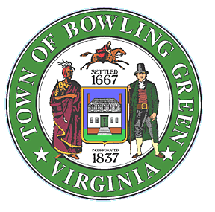

Notice of Special Meeting
In accordance with the Bowling Green Town Charter the Town Clerk, in accordance with a written request from the Mayor, has scheduled a Special Meeting of the Town Council of the Town of Bowling Green for Tuesday, November 28, 2023 at 6:00 PM at Bowling Green Town Hall, located at 117 Butler Street to discuss the selection and appointment of a Town Manager. No other business will be transacted at the special meeting unless all members of the Town Council are present and consent to the transaction of such other business. All meetings of the Council are open to the public except where in the judgment of the Council the public welfare shall require an executive meeting allowed under Virginia State Code.

Patricia Chenault, Town Clerk
Town of Bowling Green, Virginia

